CS559 Group Project Summary - Group 2:

Contributors: Prutha Trivedi, Ryan Hu, Sameer Sethuram, Xiaotong Feng

# 3.2

# **Cluster Report:**

Number of clusters/subgroups: 6

Number of y = 0: 5,609

Number of y = 1: 198

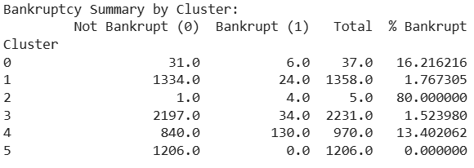

# TOP 10 CONTRIBUTING FEATURES FOR EACH SUBGROUP

*Cluster 0 - Top 10 Contributing Features:*

| **Feature Name** | **Contribution** |
| --- | --- |
| Borrowing dependency | 0.459357 |
| Working Capital/Equity | 0.408724 |
| Net Income to Stockholder's Equity | 0.372058 |
| Cash Flow to Equity | 0.359115 |
| Inventory and accounts receivable/Net value | 0.297313 |
| Accounts Receivable Turnover | 0.233757 |
| Average Collection Days | 0.215721 |
| Total debt/Total net worth | 0.189792 |
| Equity to Long-term Liability | 0.186646 |
| Total Asset Return Growth Rate Ratio | 0.118938 |

*Cluster 1 - Top 10 Contributing Features:*

| **Feature Name** | **Contribution** |
| --- | --- |
| Cash Flow Per Share | 0.512697 |
| Cash Reinvestment % | 0.420786 |
| CFO to Assets | 0.328006 |
| Total Asset Return Growth Rate Ratio | 0.254415 |
| Operating profit per person | 0.220761 |
| Total Asset Growth Rate | 0.205197 |
| Net Value Growth Rate | 0.205111 |
| Operating Profit Growth Rate | 0.178053 |
| Inventory and accounts receivable/Net value | 0.167437 |
| Current Asset Turnover Rate | 0.150367 |

*Cluster 2 - Top 10 Contributing Features:*

| **Feature Name** | **Contribution** |
| --- | --- |
| Inventory and accounts receivable/Net value | 0.466427 |
| Net Value Growth Rate | 0.439378 |
| Borrowing dependency | 0.423351 |
| Working Capital/Equity | 0.378508 |
| Net Income to Stockholder's Equity | 0.314465 |
| Cash Flow to Equity | 0.278765 |
| Equity to Long-term Liability | 0.200317 |
| No-credit Interval | 0.098539 |
| Operating Profit Per Share (Yuan ¥) | 0.086770 |
| Cash Reinvestment % | 0.067553 |

*Cluster 3 - Top 10 Contributing Features:*

| **Feature Name** | **Contribution** |
| --- | --- |
| Allocation rate per person | 0.427757 |
| Fixed Assets Turnover Frequency | 0.380232 |
| Total assets to GNP price | 0.335249 |
| Quick Assets/Total Assets | 0.234770 |
| Fixed Assets to Assets | 0.228958 |
| Current Liability to Liability | 0.218294 |
| Total expense/Assets | 0.215294 |
| Equity to Long-term Liability | 0.200287 |
| Current Asset Turnover Rate | 0.188668 |
| Operating Expense Rate | 0.179996 |

*Cluster 4 - Top 10 Contributing Features:*

| **Feature Name** | **Contribution** |
| --- | --- |
| Operating Profit Rate | 0.371677 |
| Operating Funds to Liability | 0.314562 |
| Cash flow rate | 0.264187 |
| Equity to Liability | 0.247329 |
| Working Capital to Total Assets | 0.232967 |
| Quick Ratio | 0.225846 |
| Cash Flow to Liability | 0.217950 |
| CFO to Assets | 0.199082 |
| Total debt/Total net worth | 0.192184 |
| Equity to Long-term Liability | 0.189875 |

*Cluster 5 - Top 10 Contributing Features:*

| Feature Name | Explained Variance Ratio |
| --- | --- |
| Cash Flow Per Share | 0.344326 |
| ROA(C) before interest and depreciation before interest | 0.285647 |
| Operating Profit Per Share (Yuan ¥) | 0.281607 |
| Operating Funds to Liability | 0.279599 |
| CFO to Assets | 0.277786 |
| Cash Flow to Liability | 0.267007 |
| Cash Flow to Total Assets | 0.265539 |
| Cash flow rate | 0.259342 |
| Retained Earnings to Total Assets | 0.257248 |
| Cash Reinvestment % | 0.221456 |

## 

## 

## **3.3 Result Table:**

| Subgroup ID | Name of Student | Average accuracy score base models [TT(TF)] | Accuracy score Meta Model [TT(TF)] | *Nfeatures* |
| --- | --- | --- | --- | --- |
| 0 | Ryan Hu | 1.00 [6(0)] | 1.00 [6(0)] | 25 |
| 1 | Sameer Sethuram | 1.00 [24(0)] | 1.00 [24(0)] | 18 |
| 2 | Ryan Hu | 1.00 [4(0)] | 1.00 [4(0)] | 5 |
| 3 | Prutha Trivedi | 1.00[34(0)] | 1.00[34(0)] | 21 |
| 4 | Xiaotong Feng | 0.9974 [129.67(0.33)] | 1.00 [130(0)] | 21 |
| 5 | Constant | 1.00 [0(0)] | 1.00 [0(0)] | 0 |
| team |  | 0.9996 [198(0)] | 1.00 [198(0)] | 15.954 |

# 

# Confusion Matrix for Cluster 0 Model (Ryan Hu):

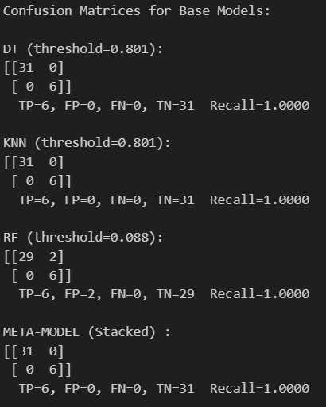

# Confusion Matrix for Cluster 1 Model (Sameer Sethuram):

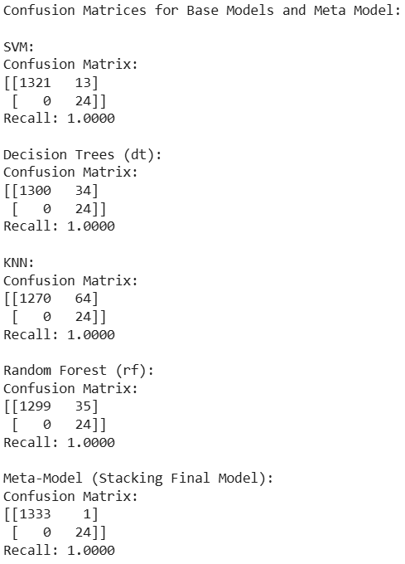

# Confusion Matrix for Cluster 2 (Ryan Hu):

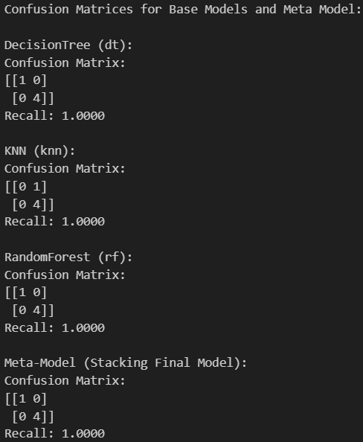

# Confusion Matrix for Cluster 3 (Prutha Trivedi):

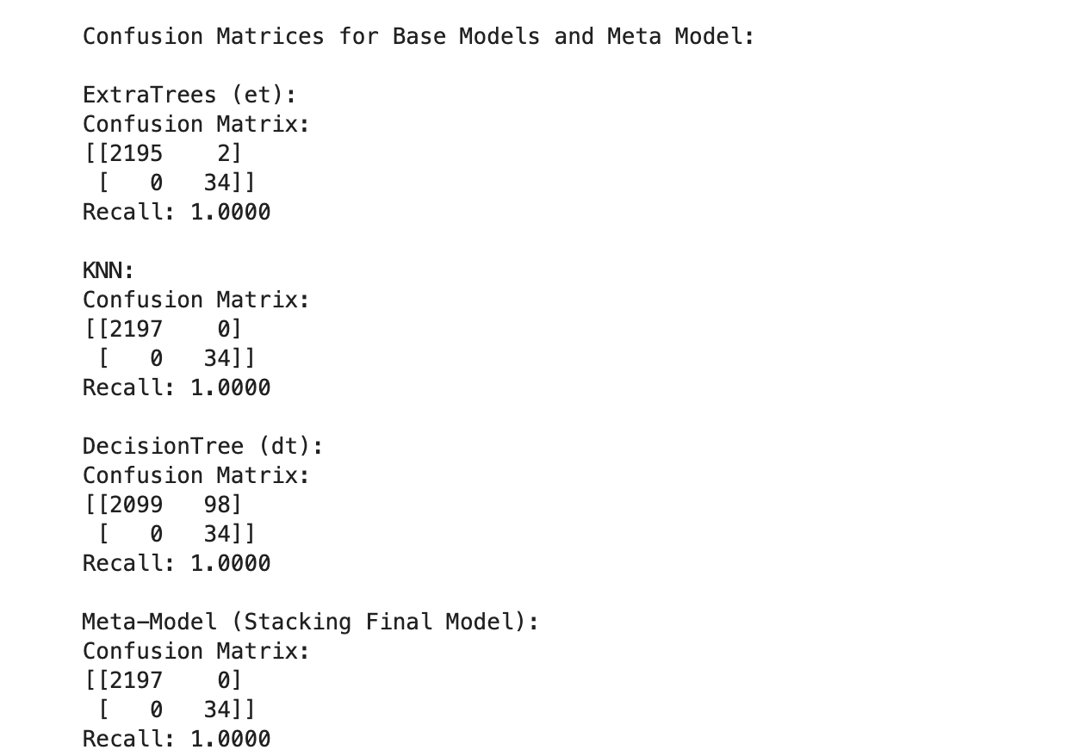

# Confusion Matrix for Cluster 4 (Xiaotong Feng):

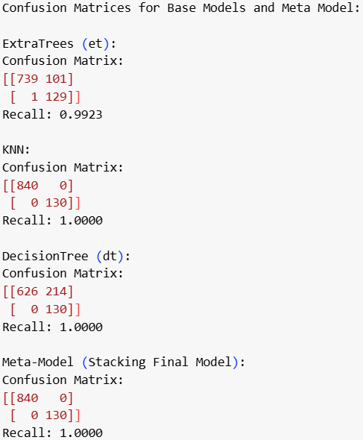

# Confusion Matrix for Cluster 5 (N/A):

Confusion matrix for cluster 5 is unavailable, as it is a constant subgroup.